X
Touch-
Y
Intelligent Ink Jet Printer

A series general-purpose for Touch
The operation manual of
the Jet printer

Please read the instruction manual carefully before using and keep it properly.
The picture related to this manual for reference only. All contents are checked and proofread. If there are any problems such as printing errors, please understand.

Product warranty card
In the case of normal use and care, if any product quality problems are found, the company will repair or replace it for free.
Model： Dealer：
Number： |  |  | Date of  purchase：
Note：
Product warranty  period | product | Warranty period
Product warranty  period | Ink jet printer | One
Cause of issue：
Tel：

Disclaimer：
- During the use of this product, if there is serous damage, accidental fire, water ingress, unexplained chemical corrosion, unauthorized disassembly, etc, it isn’t covered by the warranty.
- If the printer has malfunctioned, please back up the information in time to prevent loss before repairs.

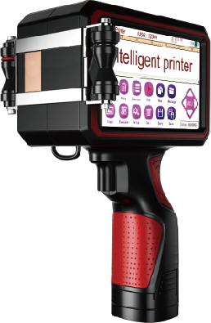
②
①
③
④
⑤
⑥

Handheld jet printer Positive

1、The handle (inside the battery) 2、Print switch
3、Auxiliary wheel 4、Nozzle slot
5、Edit function area 6、Display area

⑬
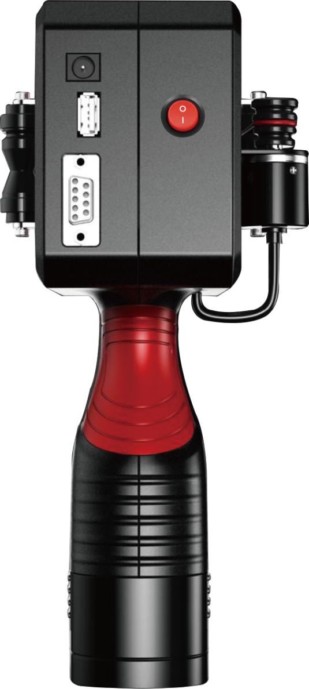
⑦
⑧
⑨
⑩
⑪
⑫

Handheld jet printer other side

7、232 serial port 8、Auxiliary wheel
9、USB serial port 10、Charging interface
11、Synchronizer 12、Transmission belt
13、Power switch

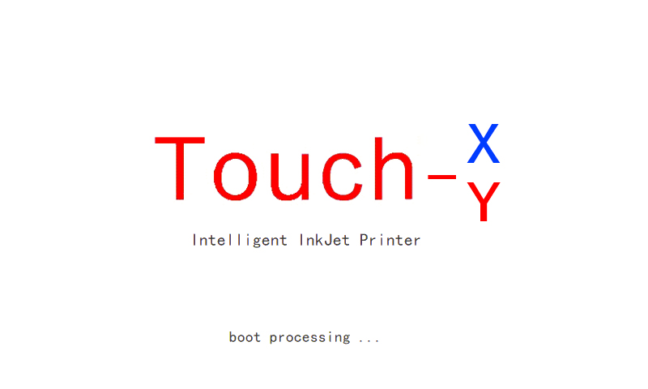

Boot page

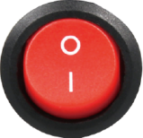
Click on the power switch
And turn on the boot page

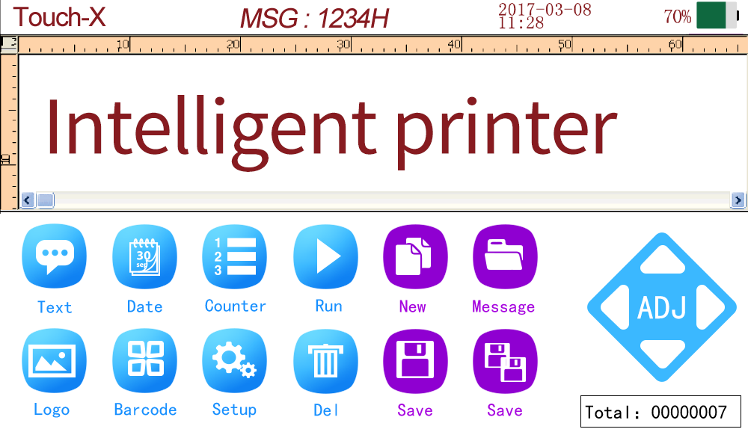
（T-X main menu）
 | You can edit Chinese, number, English, symbols, and so on. |  | Delete the information segment that has been edited.
 | Edit variable in year, month, day, hour, minute and second. |  | Create a new information segment.
 | Edit a variable sequence number. |  | Select the name of the information that has been saved
 | Click Run to star printing or stop printing. |  | Reedit the information name
 | Edit the trade mark or logo. |  | Reedit the information name
 | Edited bar code and QR code. |  | Minute movement of information segment position
 | Setting system parameters ( If needs to be operated under the guidance of the engineer) |  | Check the number of printing
 | Percentage of battery power consumption ( For general reference only) | MSG: | Current information name

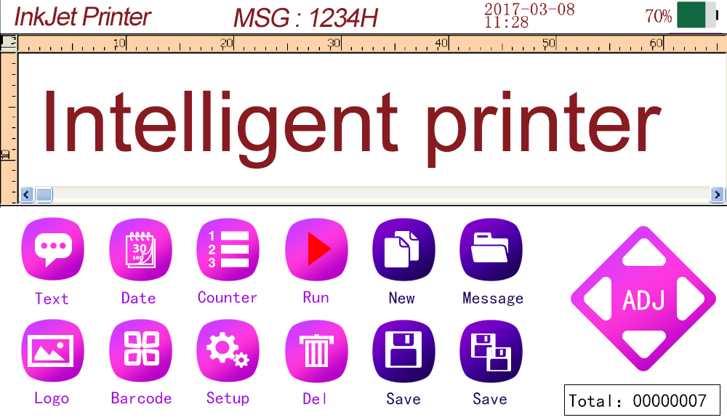

（T-Y main menu）
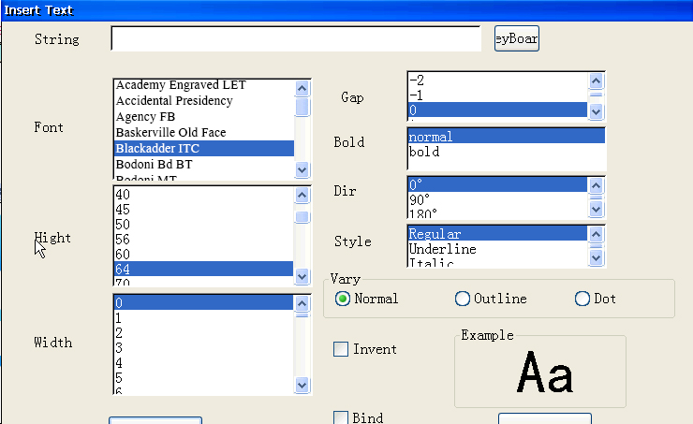
New editing text

Printing the font: click the text to enter the picture above, and edit Chinese, English, number, symbol, etc. The font can be selected ti change the font height. Character spacing fine tuning, characters can choose thickness, direction, character style can be underlined, can tilt characters. Character effects are normal, dot matrix and hollow. ( width of the dot matrix must be 0).
Edit variable data
Touch-X：The highest printing height is 12.7mm
Touch-Y：The highest printing height is 25.4mm
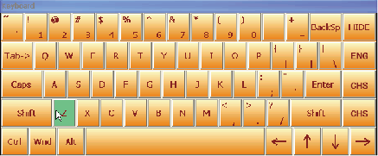
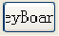
Edit text : Click the keyboard to pop up the keyboard interface, then you can edit the contents what you want to print.
Deleting character Edit English numbers Hidden keyboard
The mouse cursor move to the tail
Lock up the capital letters
Change Message
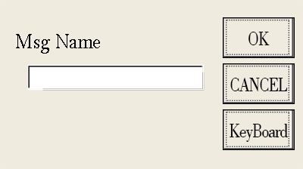
Insert Counter

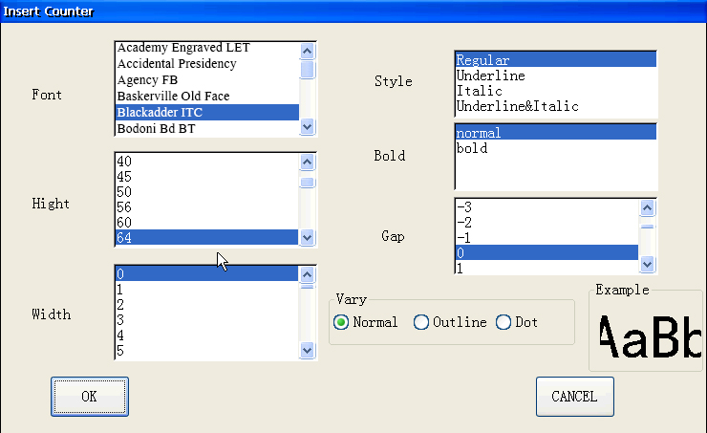
Font: The font can be chosen freely
Height: The highest printing height is 25.4mm(T-X is 12.7mm), the height can be chosen.
Style: underline, tilt, underline and tilt.
Font size can be added. You can choose the font spacing. Special effects are normal, hollow and dot matrix. (width of the dot matrix must be 0).

Insert Logo
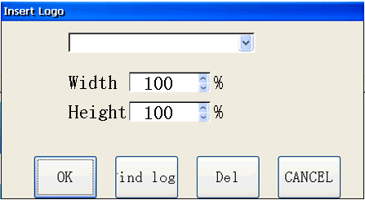

Logo printing: the U disk can be imported into the picture, and it must be BMP format. The image height is in 12.7mm. (T-Y machine image height is within 25.4mm)

The numerical range is 0-100. The picture width can be adjusted.

The numerical range is 0-100. The picture height can be adjusted.

QR

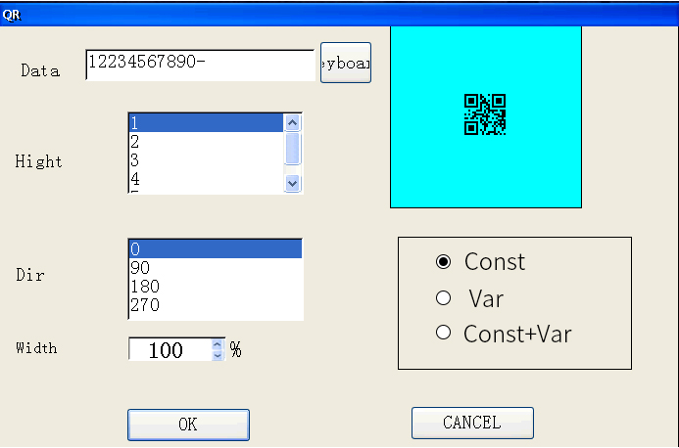
Constant: enter number in the data bar to generate fixed QR code.
Variable: through the data. Txt file in the U disk, the data is refreshed and imported to the inkjet printer, which generates two-dimensional code inkjet printing in sequence. [ unable to select order] the data column will automatically generate 0 digits equal to the variable length.
Constant + variable: Enter a fixed character in the data bar, then import the variable data in the U disk, to generate the complete content of the QR code.
For example: China 1234, China 4567, China ABCD……
Note: 1. the machine starts 15 seconds to enter the main page and then insert the U disk.
2.The use of U disk memory can not exceed 8G
3. do not directly modify the contents of the data.txt file in the U disk.
Insertion time and date
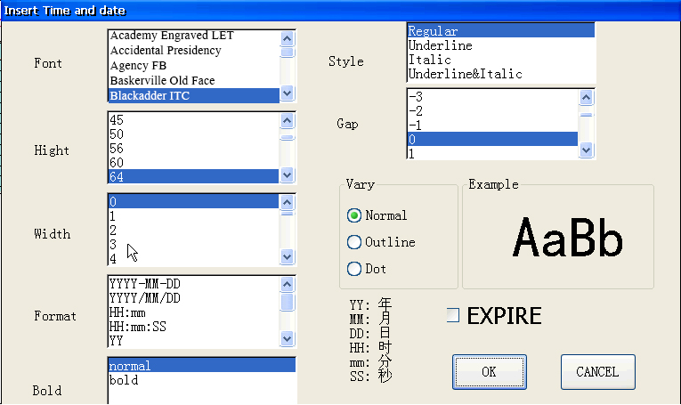
Jet printing time: time synchronization software. The font and width can be changed to a maximum height of 25.4mm ( T-X=12.7mm). You can change the thickness style and choose character interval. Special effects are normal, dot matrix and hollow. ( width of the dot matrix must be 0).

Format selection: If you need yyyy-mm-dd,MM:SS insertion time variable as a whole, please choose the same width font ( such as bold is the same width font). If a special order is required, a single variable unit can be inserted one by one. ( ss:DD:YY, i.e.:Seconds:Day:year)

Insert Barcode
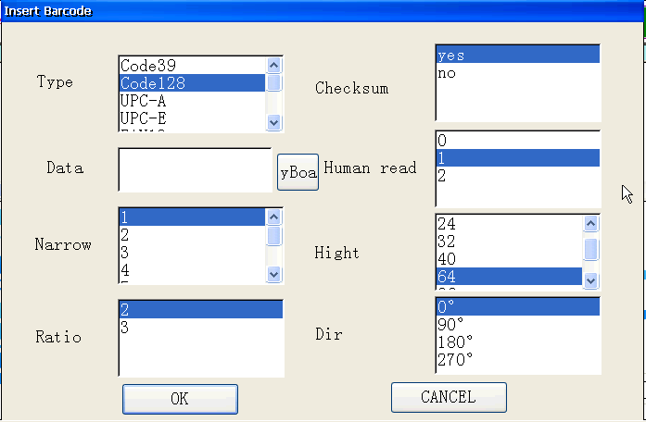
Type: selectable bar code type ( such as code39, code128, UFC-A, QR)
Data: use a keyboard to enter digital or English
Gap: Gap width from 1-8
Ratio: you can choose 2 or 3
Checksum: Check code, you can choose to yes or no
Human read: You can choose 0, 1, or 2
Hight: Jet printing height, such as 16, 24, 32, 40 etc
Dir: Jet printing direction, you can choose 0°, 90°,180°,270°
Spray Settings
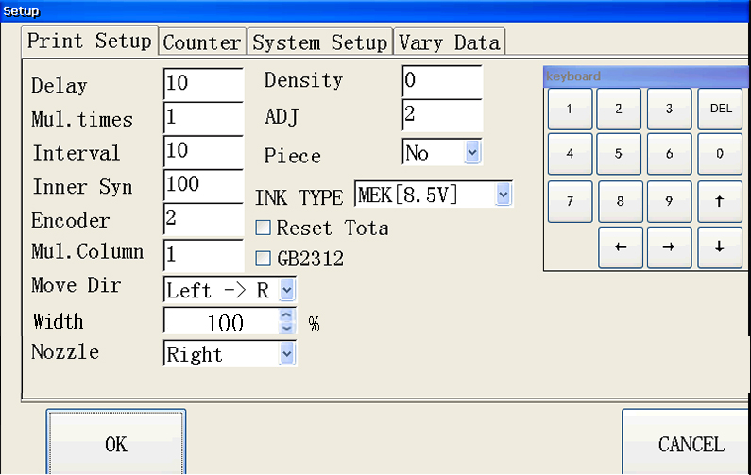
Delay: After the spray is triggered, the printing is extended for a period time.
Speed of printing: It is effective only when the width of the sync word is 0. The bigger the value, the faster the speed is. ( Dedicated online machine usually use ‘1-4’. An online printer can only use ‘0’
Nozzle: Nozzle selection. Left Nozzle, Right Nozzle, Double Nozzles (No nozzle selection function of T-Y machine)
Mul.time: The number of times that can be triggered
Interval: Distance between continuous printing information
Move Dir: The relative position of the left and right nozzles ( Only in double nozzles)
Ink type: Users must select the voltage according to the actual cartridge type. (The voltage value of the ink box of the T-Y jet printer rises by 0.5V)
Density: Pulse width. The suggestion is not to be modified
Reset Total: Reset total number, it is necessary to reboot the printing information to be effective
Piece: 1. divided into 5 segments at most.
2. the transverse tension must be 100%
3. Paragraphs can not be overlapped.
4. use the deadline and normal insertion time as a paragraph.
5. the vertical arrangement of variable is also considered as a paragraph, even if it is edited in segments.
Settings/counter
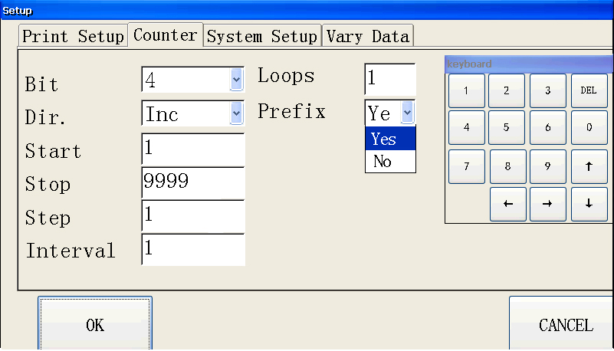
Digit: Counting digits
Direction: Plus count/ Less count
Initial value: Counting start value
End value: End of count
Step number: Count the changing step size
Eepetitions: Number of repetitions of the same number
Cycle time: Number of valid cycles for counting values (0 is infinite loop)
Prefix: Yes (E.g 0001/0002/0003)
No (E.g 1/2/3)
Settings/System Settings

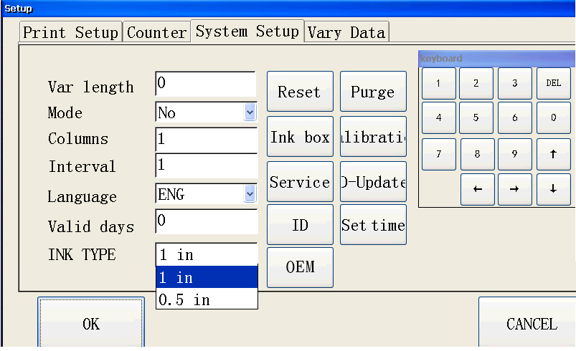
Variable length: Character length when text is bound as a variable (0-100 digit)
Flash spray mode: No (No flash) Yes (Have flash)
Flash columns: Flash columns
Flash Interval: Pause time between flashes
Language selection: selected, English or Chinese
Valid days: Calculated as of this date
Time setting: date and time setting of the printer system
Screen Calibration: Touch Screen Position Calibration
Reset: Clear the message name and picture with a button
Cleaning: Forcing the nozzle to eject ink ( must be placed in front of the cartridge) Click again to stop cleaning
Print Control Update: Resetting the print Control Board Procedure ( contact factory for instructions)
Cartridge type: 1 inch and half inch ( only T-Y machine supports this function)
OEM
Click on the button, modify the upper left corner of the machine display information, settings completed, restart effective
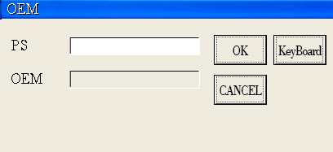

Settings/Service
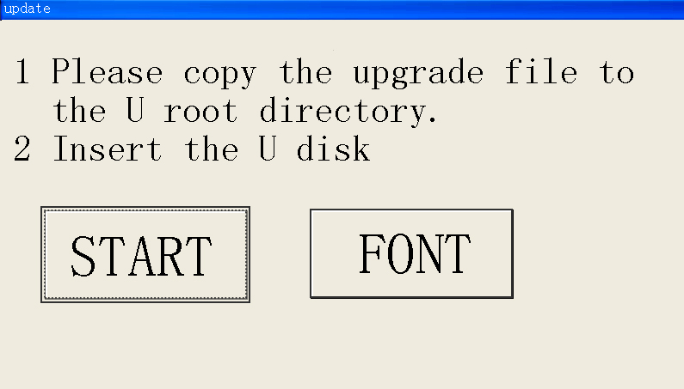

Click the FONT button to enter the font selection interface.
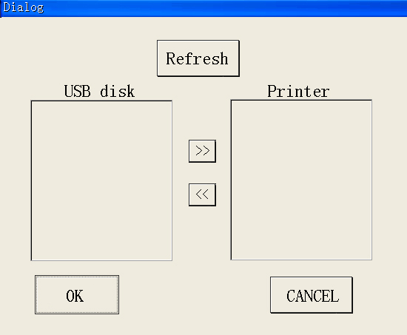
The T-XY inkjet printer can increase or decrease the font of the system through the U disk。

Click refresh button to automatically refresh the U disk and the document in the inkjet printer.

Select the font file in the USB disk list and click the right arrow to import the font file from the USB disk into the printer

Select the font file in the Printer list and click the left arrow to remove the font file from the printer.

Settings/U disk variable data

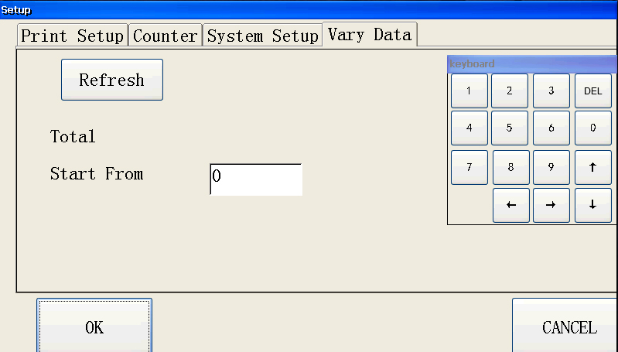
U disk refresh: Refresh U disk data
Starting from the first few items: select the initial printing data entry
Requirements for U disk:
- Choose genuine quality U disk, memory should not be too large, 4-8G that will do
- U disk should not be stored too much content with inkjet printing. For example, pictures or videos.

Database variable settings
- Functional description
Print the specified txt files in the U disk by line

File preparation, in the U disk’s root directory, create a new “data.txt” text file, (must be data file name), and meet the following requirements: printing data in units of behavior, each line must be the same length, the file ends with “$$”.

As shown in the picture
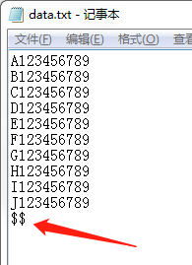
END

- Plug in the U disk, click on the settings, enter the “U disk variable data” menu, [The machine starts 15 seconds to enter the main page and then insert the U disk.]
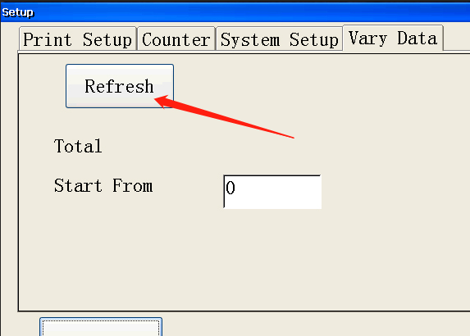
Point U disk refresh, the system displays the total number of lines of the file and the number of characters per line, and it can be freely selected from the first few lines to start printing. Press the OK key, and data.txt file. Import the system, and you can unplug the U disk.

- Click on the text to insert, click on the keyboard, enter a number, such as the number 1, at the same time select the font, height, width and other parameters, ( Be sure to type in the bindings, and automatically generate zero digits equal to the variable length in the string bar)
√
②
①
1234567890
After setting up other printing parameters, you can start printing, in the NEST variable data area. Display variable content next time until all data is finished, then stop printing.

If there is something unclear, please contact our sales or service engineer.

Printer packing list
No | Part name | Qty | Exterior | Handheld | Online
1 | High-end chassis | 1 | 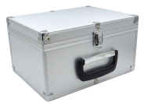 | ★ | ★
2 | Hand-held inkjet printer | 1 | 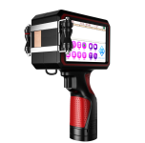 | ★
3 | Online inkjet printer | 1 | 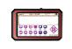 |  | ★
4 | Charger  (16.8V 1A) | 1 | 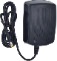 | ★
5 | Adapter  (16V-3A) | 1 | 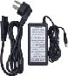 |  | ★

Note: Online inkjet printers should add bracket and sensor.

Note:“★”to be standard,“〇”pay for
No | Part name | Qty | Exterior | Handheld | online
8 | screwdriver | 1 |  | ★ | ★
9 | Photoelectric sensors | 1 |  |  | ★
10 | O-ring | 5 |  | ★
11 | Ink cartridge | 1 | 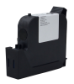 | 〇 | 〇
12 | Stylus | 1 | 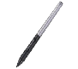 | ★ | ★
13 | Printer operation manual | 1 | 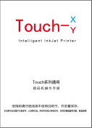 | ★ | ★
14 | mouse | 1 | 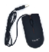 | ★ | ★

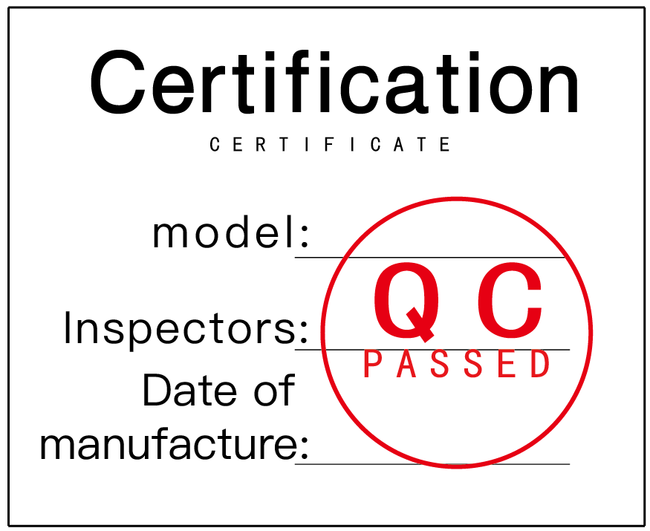
Precautions:
- In the course of using this product, if there is serious collision, open fire, water intake, corrosion of unknown chemical substances, disassembly and other man-made damage, are not within the scope of warranty.
- If the machine is in trouble, please backup the important information in the equipment before repair, so as to prevent loss.
- If the code jet machine is in abnormal use, please contact the maintenance engineer or call the power plant home service line at the first time.
- Untrained personnel are strictly forbidden to operate and use inkjet printer.
- It is strictly forbidden to dismantle the inkjet printer without permission from the staff of the factory.
- The operator of the inkjet printer must read the instructions carefully before operating on the machine.
The final interpretation right of the disclaimer belongs to the company

Ink cartridge usage precautions
- To install the ink cartridges and unload the ink cartridges, you must cut off the power of the machine firstly.
- Do not use the device for more than 20 minutes. The ink cartridge must be removed from the device.
( And use the card holder to be stuck, be sure to keep the card holder well)
- HP Company advise, after the ink cartridge is opened, it is better to use it up within 3 months.
- Because of the ink cartridge is fast drying, there is a little drawing, the lack of line situation.
- If there is drawing, lack of line situation:
- We can use a soft tissue to wipe the nozzle in one direction, ( cannot damage the nozzle with hard goods)
- After one message is sent to another nozzle ( left or right), running the device again.
- If it is a quick-drying white link, shake it for 5-10 minutes before each use. Otherwise the color will be lighter. ( Note that shaking should not be too strong)
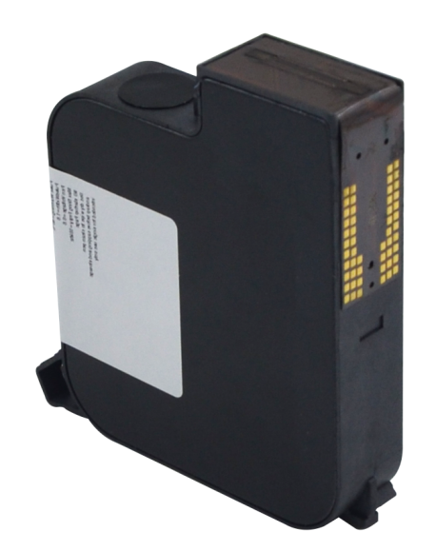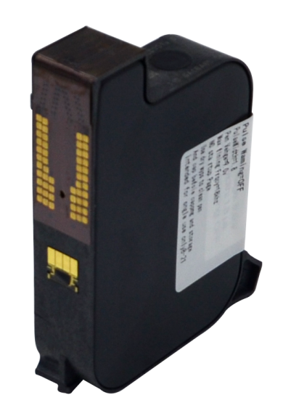
1 inch ink cartridge 1/2 inch ink cartridge

Technical parameter
Machine size | 140*80*235mm (include handheld)
Weight | About 800g(without ink cartridge)
Screen size | 5 inchs touch screen (108*65mm)
Store information | Infinite storage
Segmenting function | 5 sections
Precision of printing | 300-600DPI
Counting unit | 1-8 digits
Printing bar code | Bar code, QR code, variable QR code
External interface | Charging interface, R232 serial port, USB
Using environment | Temper:0-40℃、humidity:10-80%
Oily ink | Black, red, blue, green, yellow, invisible
Quick drying ink | Black, red, blue, green, yellow, orange, white, invisible
Ink cartridge capacity | 42CC（half inch）、45CC（1 inch）
Ink type | Dry, oily, water-based
Spray print library | Synchronize with machines and computers
Spray printing distance | 2-5mm
Jet printing height | 2-12.7mm（T-Y is 25.4mm）
Speed of printing | 60m/min
Printing content | Date, counting, batch number, serial number, pictures etc
Power parameter | DC 16.8V lithium battery;  16V3A the power adapter
This parameter is subject to change without notice

