T-t Inkjet Printer

User’s Manual

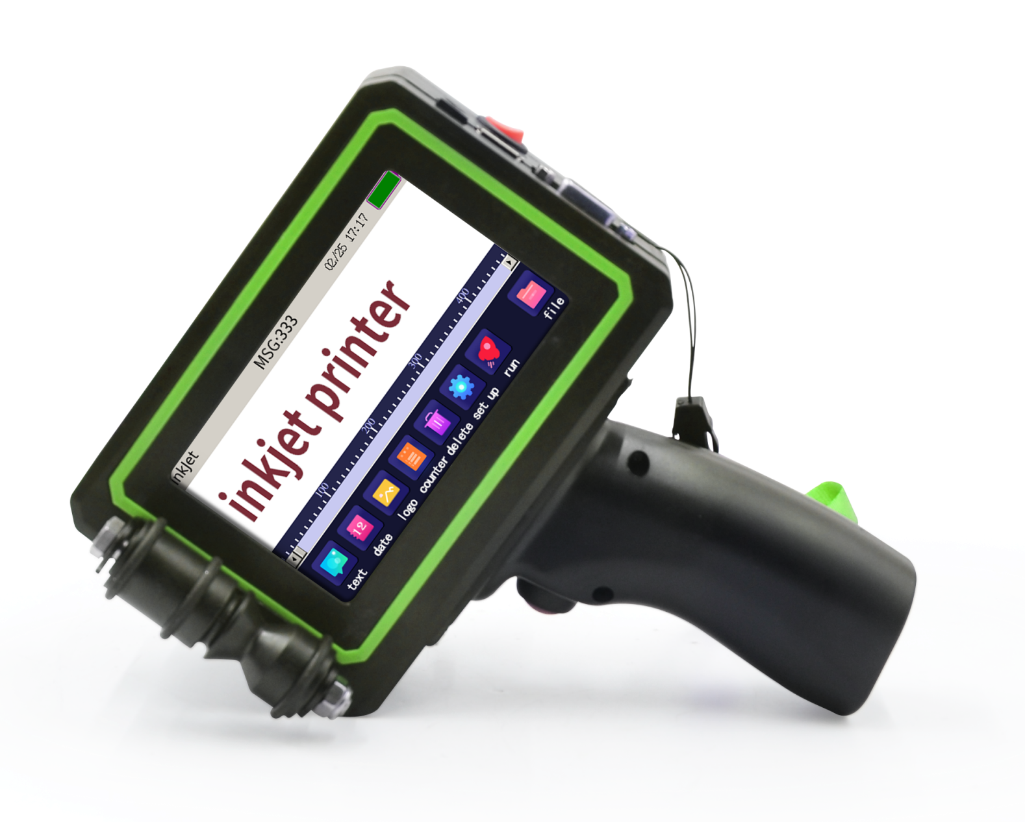



Touch-t
Intelligent Printer

Touch-t hand-held printer

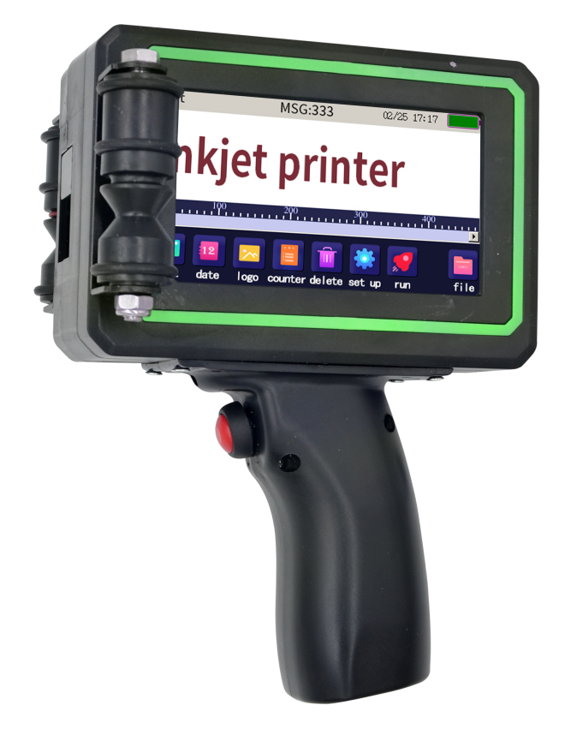

Touch panel

Nozzle
Roller

Print Switch

Handle

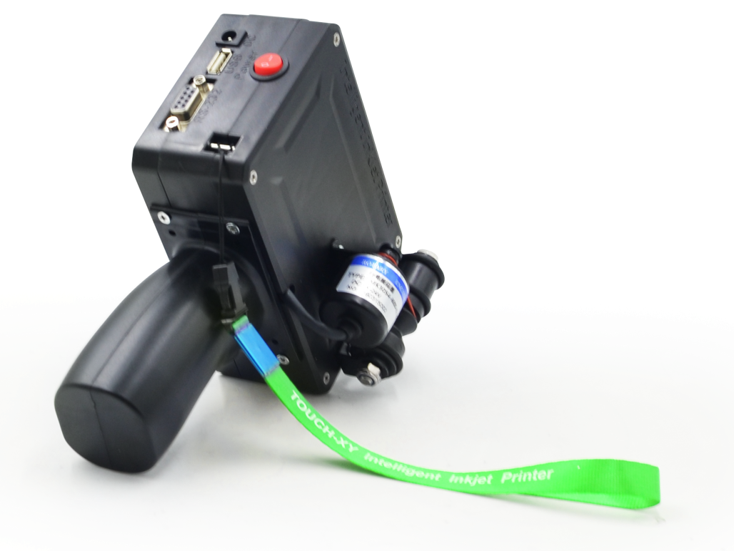
Power Switch
Power Interface
U disk Interface
232 serial port

Leather collar
Synchronizer

Touch-t online printer

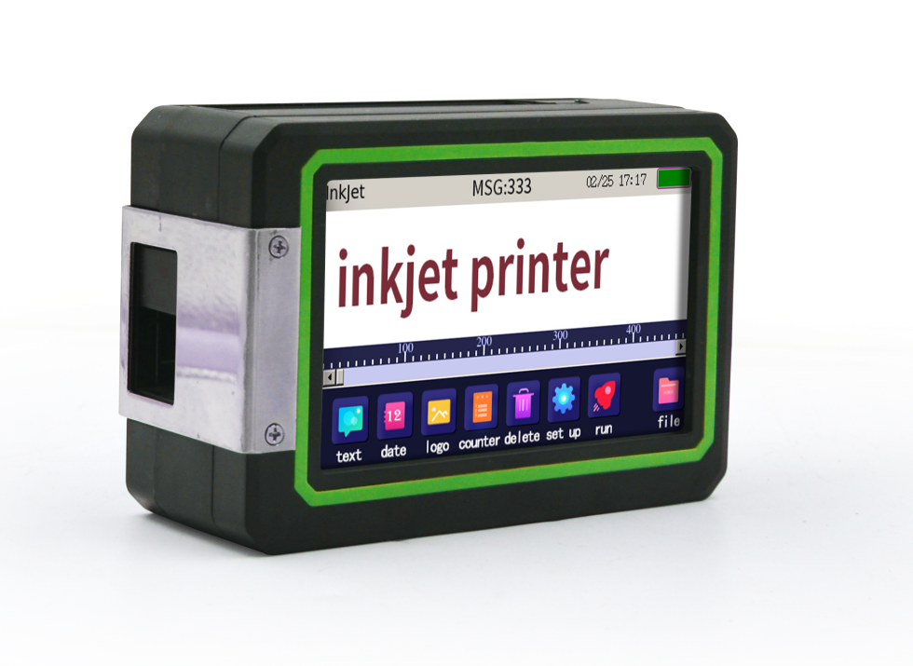

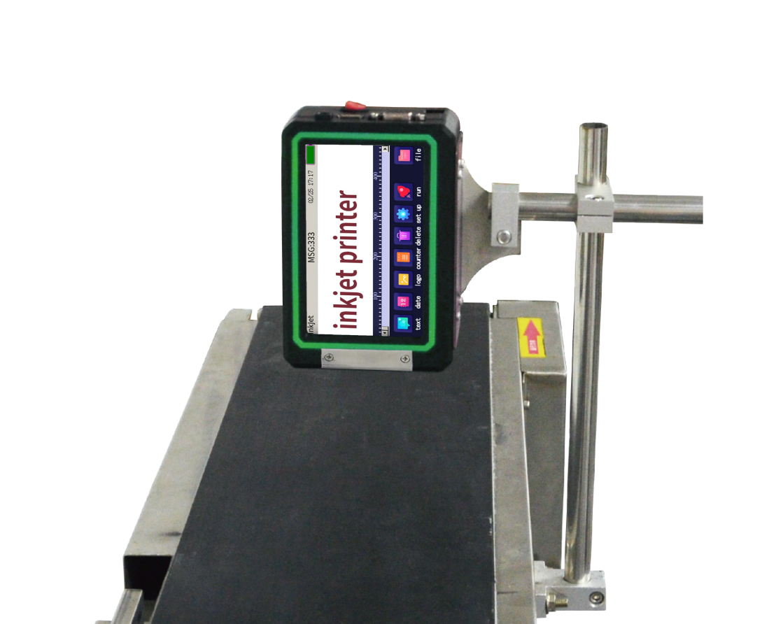

Explanation of function key

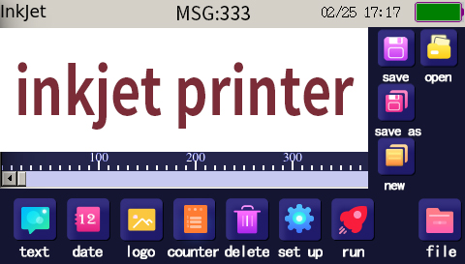

 | Editable number, text, symbols, etc. |  | Delete edited information segments
 | Editable variables year, month, day, hour, minute, second |  | Select the file
 | Editable variable serial number, regular number |  | Create a new message
 | Start to print or stop printing |  | Open saved information
 | Editable trademark, Logo |  | Save edited information
 | Editable barcode and QR code |  | Save an additional information name
 | System parameters can be set (Under the guidance of engineers) | MSG： | Current printable information name
 | Battery remainder (for general reference only)

Operation instructions

New Text
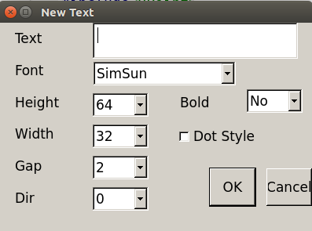
Printing font: Click on the text to enter, you can edit English, numbers, symbols and so on. The font style can be selected. The height of the font is adjustable, the maximum height is 12.7mm. Characters can be selected in thickness and direction. Printing effects are normal and dot matrix.
Keyboard
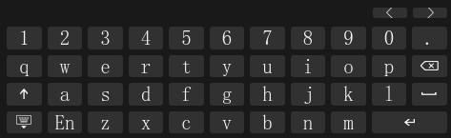
Caps Lock Hidden keyboard Language switching

Numeric keypad
The keypad can be dragged and can be used to quickly modify numbers.
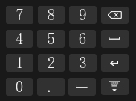
New Time
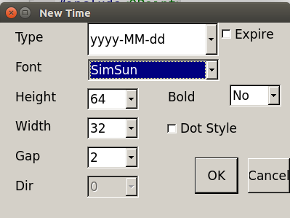
Printing time: time can be synchronized with software. The font style can be selected. The height of the font is adjustable, the maximum height is 12.7mm. Characters can be selected in thickness and direction. Printing effects are normal and dot matrix. Format selection: if yyyy-mm-dd, HH:MM:SS are needed, just insert the whole time variable.

If special personalized ordered needed, individual variable units are required to insert one by one. (e.g. ss:DD:YY, seconds:days:years)
Lattice effect: If checked, spray printing shows dot effect.
Deadline: If checked, the deadline can be set.

New Logo
Printing Logo: Pictures can be imported to print with U disk, must be in BMP format, the height of the picture is within 12.7mm.

Requirements for U-disk:
- Choose genuine high-quality U-disk, memory should not be too large, 4-8G can be.
- It is not advisable to store too much content unrelated to jet printing on U-disk.
For example: pictures or videos

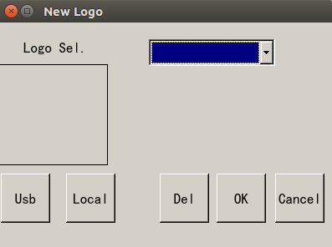
U Disk: Import pictures from U disk
Local: Pictures already stored locally

New Barcode
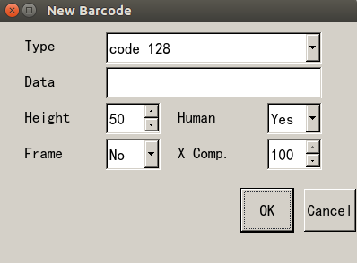
Type: Barcode types, such as code39, code128, UFC-A, QR code.
Data: Use the keyboard to enter numbers or English.
Height: 16, 24, 32,40, etc.
Human: Optional yes or no.
X Comp:Horizontal percentage. It can be used to reduce printing width.

Delete information
To delete the information segment of the visual area.
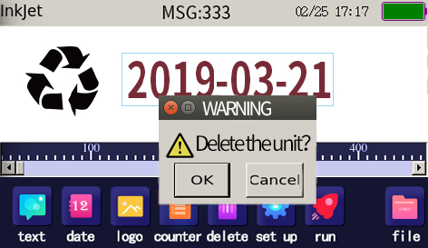

New Counter
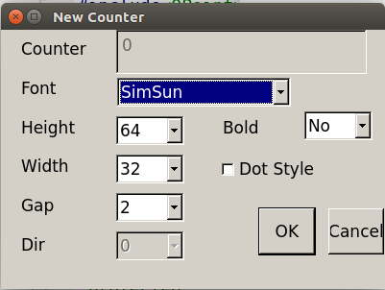
Font: bold, special dot matrix fonts and other commonly used fonts
Height: up to 12.7mm, optional height.

System/Printer
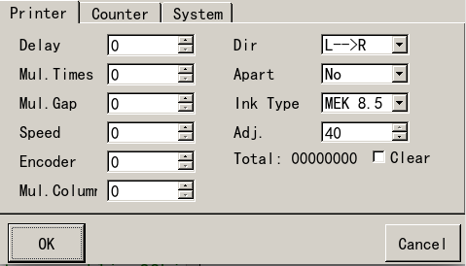
Delay: There is a delay between triggering printing switch and starting printing.
Speed Only when the synchronous word width is 0, the greater the value, the faster the inking speed.
(Special for on-line machine, extreme value 240)

System/Counter
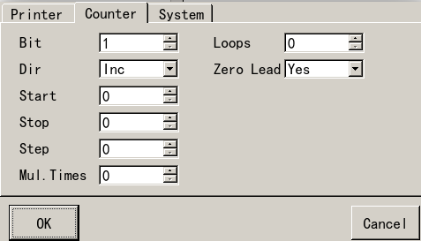

Bit: Number of digits (1-8 digits)
Dir: add count, subtract count
Start: the starting value of the count
Stop: the end value of the count
Step: counting the steps of change
Mul.Times: Frequency of counting changes
Loops: Number of cycles counting valid values (infinite cycles at 0)
Zero Load: Yes (e.g. 001, 002, 003), No (e.g. 1, 2, 3)

System/System
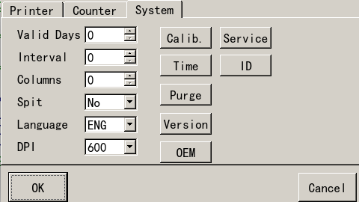
Valid days: calculate the deadline from present
Interval: pause time between flash sprays
Columns: number of flash inkjet columns
Spit: No-Noflash spray, Yes-have flash spray
Language: Chinese and English are optional
DPI: 300-single injection, 600-Double injection
Calib: Calibration on touch screen position
Time: Date and time settings of printer system
Purgo: Strong inkjet cartridge (shade must be placed before cartridge), must be in the state of printing.
In this state, click again to stop cleaning
Version: Enter this mode and upgrade APP (contact manufacturer to guide operation)
OEM: Enter password to modify the main interface from left view (password: 888888)

Cartridge Use Attention

- The power supply of the machine must be cut off before pulling cartridge.
- If you do not use the machine more than 20 minutes, you must remove the cartridge from the machine. And clamp it with a clip.[Be sure to keep the clip well]
- It is better to use the cartridge within three months after it is opened and powered on.
- Because the cartridge is fast-drying, it is normal that a little wire drawing and line missing occur while printing.
- If the phenomenon of wire drawing and line missing occurs.
Method 1: The sprinkler can be wiped in one direction with a soft paper towel.
Method 2: After changing the vertical resolution to 300 in the advanced menu, it will be replaced with another sprinkler ( left or right) to retransmit the information for printing.
- If it is fast-drying white ink, shake it for 5-10 minutes before use, otherwise the color will be lighter. [Be careful not to shake too hard]

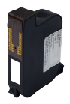

Electronic label Half inch cartridge
Do not destroy it

Dimension diagram

140mm
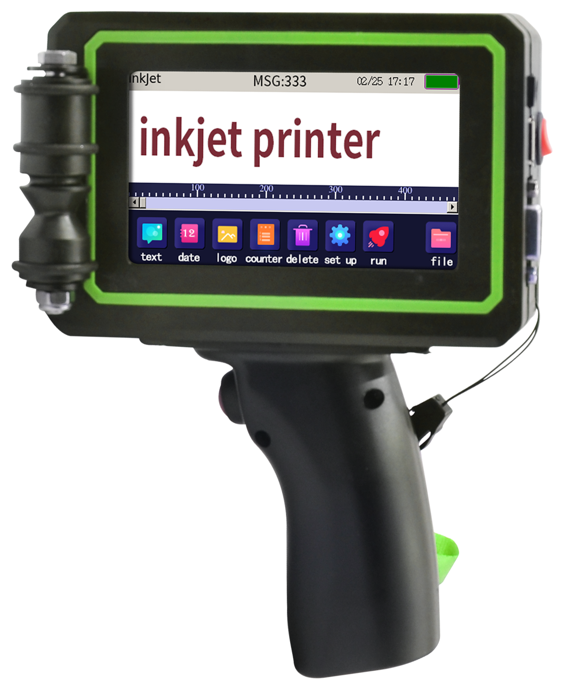

95mm

190mm

54mm
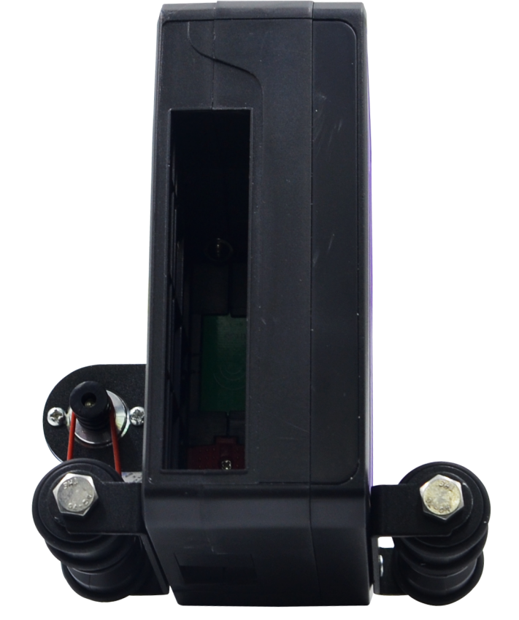

110mm

DB9 pin wiring diagram

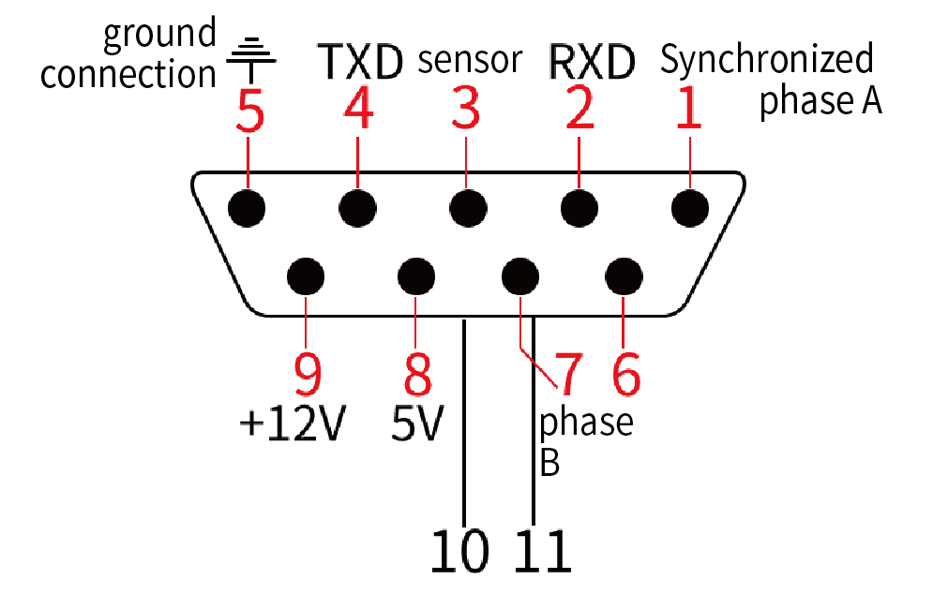
Note: TXD and RXD are 3.3V

Common accessorises

Small bracket
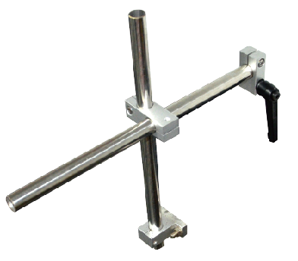

Printing Board
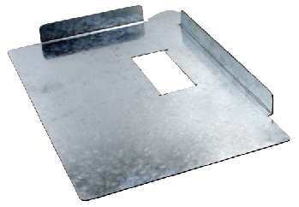

Printing Table

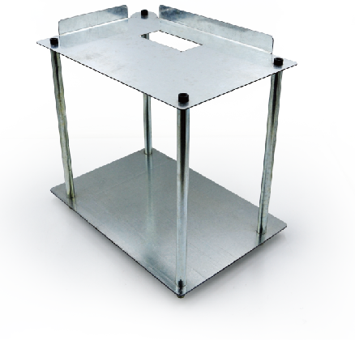

Conveyor Belt
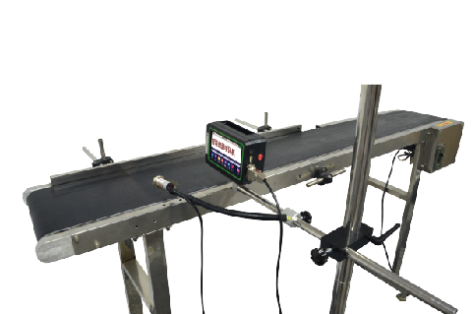
Large bracket
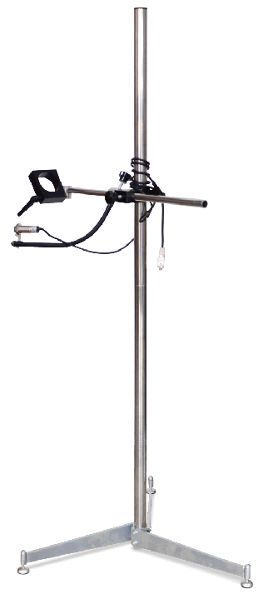

Note: The above commonly used accessories need to be purchased at extra cost.

Packing list

No | Part name | Qty | Exterior | Handheld | Online
1 | High-end  chassis | 1 |  | ★ | ★
2 | Hand-held  Inkjet printer | 1 |  | ★
3 | Online Inkjet printer | 1 | 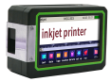 |  | ★
4 | Charger  16.8V 1A | 1 | 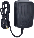 | ★
5 | Adapter  16V-3A | 1 |  |  | ★
6 | Sensors | 1 |  |  | ★
7 | O-ring | 5 |  | ★
8 | Cartridge | 1 |  | 〇 | 〇
9 | Stylus | 1 | 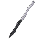 | ★ | ★
10 | Printer operation manual | 1 |  | ★ | ★

Warranty Service Card

Under normal using and caring circumstances, if product got problems in quality , the company will give free maintenance or replacement. The warranty period of product quality is shown in the table below:
Model: Dealer:
Number: |  | Date of  Purchase:
Note:
Product  Warranty  period | Product | Warranty period
Product  Warranty  period | Inkjet printer | One year
Cause of issue:
Tel:

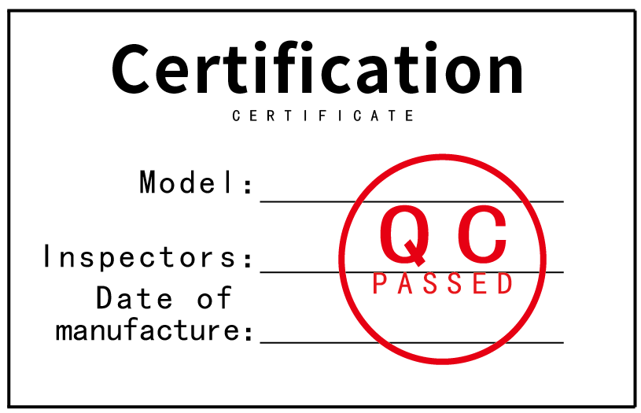

Disclaimer:
- In the course of using this product, if there are serious falls, open fire, water intake, corrosion of unknown chemicals, and personal damages, it is not within the scope of warranty.
- In case of machine failure, please backup important information in time before repairing to prevent information loss.

The final interpretation right of the disclaimer belongs to the company

